Django Sessions
Django considers the importance of sessions over the website and therefore provides you with middleware and inbuilt app which will help you generate these session IDs without much hassle.

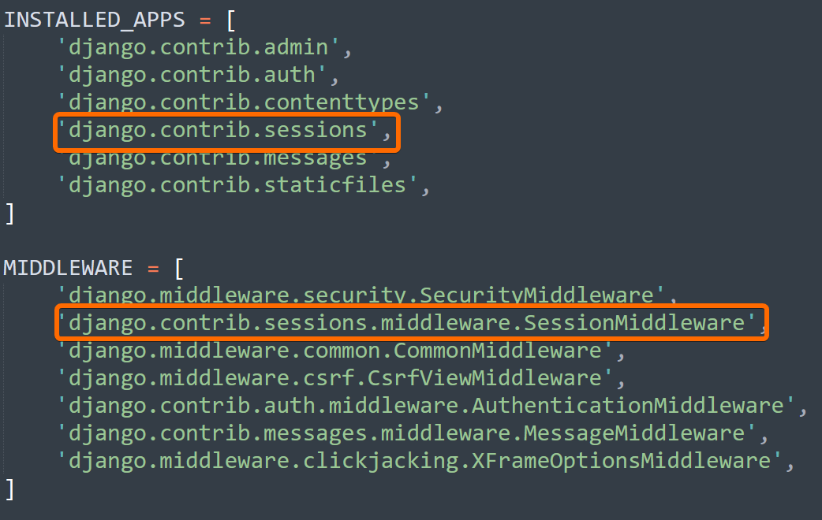

django.contrib.sessions is an application which works on middleware.SessionMiddleware and is convenient to work.

The middleware.SessionMiddleware is responsible for generating your unique Session IDs. You will also require django.contrib.sessions application, if you want to store your sessions on the database.

When we migrate the application, we can see the django_session table in the database.
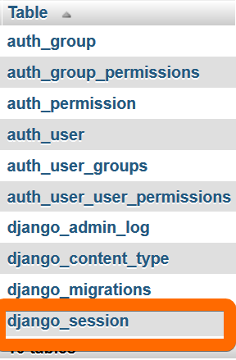
The django.contrib.sessions application is present in the list of INSTALLED_APPS in settings.py file.
For working on sessions, you will need to check whether your browser supports cookies or not.

